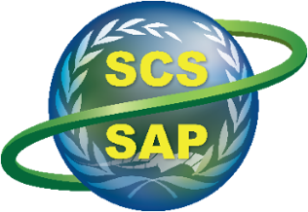
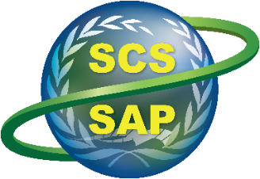
Implementing the Strategic Action Programme for the South China Sea and Gulf of Thailand
(SCS SAP Project)

Second Meeting of the Regional Working Group on Land-Based Pollution

11-12 November 2024, Shenzhen, China

PROVISIONAL LIST OF DOCUMENTS


LIST OF DOCUMENTS

Meeting Documents

The Regional Working Group on Land-based Pollution members are required to review these documents

SCSSAP RWG-LbP 2/1 Provisional Annotated Agenda
SCSSAP RWG-LbP 2/2 Status and Progress of the SCS SAP Project Implementation at Regional and National Level
SCSSAP RWG-LbP 2/3 Status of Preparation and Implementation of Land-Based Pollution Activities at National Level (Country Presentation)
SCSSAP RWG-LbP 2/4 SCS SAP Targets and Activities and Execution Arrangements for Land-Based Pollution
SCSSAP RWG-LbP 2/5 Details and Requirements in the Development and Updating of the Transboundary Diagnosis Analysis and Strategic Action Programme
SCSSAP RWG-LbP 2/6 Report of the Meeting (to be prepared following the meeting)

Information and Reference Documents

SCSSAP RWG-LbP 2/Inf.1 Provisional List of Document (this document)
SCSSAP RWG-LbP 2/Inf.2 Provisional List of Participants
SCSSAP RWG-LbP 2/Inf.3 Summary Achievements in Implementing the Strategic Action Programme (SAP)
on Land-based Pollution, 2008-2021
SCSSAP RWG-LbP 2/Inf.4 First Meeting of the Regional Working Group on Land-Based Pollution Report
SCSSAP RWG-LbP 2/Inf.5 EAS/RCU TRS No. 14 Transboundary Diagnostic Analysis for the South
China Sea
SCSSAP RWG-LbP 2/Inf.6 First Project Steering Committee Meeting Report
SCSSAP RWG-LbP 2/Inf.7 Second Project Steering Committee Meeting Report
SCSSAP RWG-LbP 2/Inf.8 First Meeting of the Regional Scientific and Technical Committee Report
SCSSAP RWG-LbP 2/Inf.9 Second Meeting of the Regional Scientific and Technical Committee Report

