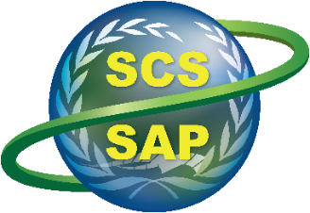
Implementing the Strategic Action Programme for the South China Sea and Gulf of Thailand (SCS SAP Project)

Second Meeting of the Regional Working Group on Land-Based Pollution

11-12 November 2024, Shenzhen, China

Summary Achievements in Implementing the Strategic Action Programme (SAP) on Land-based Pollution, 2008-2021

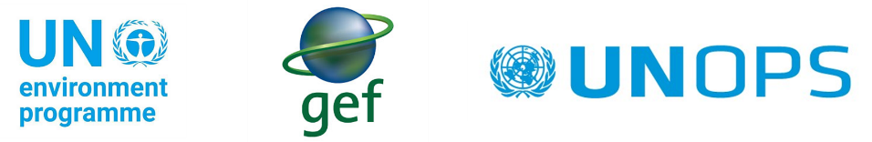

UNEP/GEF Implementing the Strategic Action Programme for the South China Sea and Gulf of Thailand (SCS SAP Project)
Summary Achievements in Implementing the Strategic Action Programme (SAP) on Land-based Pollution, 2008-2021
1/ National policies and laws, and financial mechanism for the management of land- based sources of pollution
1. 1. Update of legislative and institutional frameworks for land-based pollution management in participating countries (using multi-sectoral approaches)
Baseline in 2008: Effectiveness of existing legal and institutional frameworks limited by predominantly single sector approaches
Legislative and institutional frameworks | Time | Remark
Cambodia
Sub-degree on Management of Garbage and Solid Waste of Downtowns | 2015 | No. 113
Sub-degree on Electronic Waste | 2015
Sub-decree on wastewater management and treatment system | 2017
Sub-decree on the Management of Plastic Bags | 2017 | No. 168
Sub-decree on product and plastic waste management |  | On-going
China
Environmental Protection Law | 2014 | Revised
Marine Environmental Protection Law | 2017 | Amended
Solid Waste Pollution Prevention and Control Law | 2020 | Amended
Environmental Impact Assessment Law | 2018 | Amended
Wetland Protection Law | 2021
Indonesia
Solid Waste Management Act | 2008 | No. 18/2008
Environmental Management Act. | 2009 | No. 32/2009
Philippines
Three (3) Major Laws of the Philippines That Concern on the Management of Land-based Pollution:  - Clean Water Act (CWA) (Republic Act [RA] 9275; 2004);  - Ecological Solid Waste Management Act (ESWMA) (RA 9003; 2001);  - Toxic Substances and Hazardous and Nuclear Waste Management Act (TSHNWMA) (RA 6969; 1990) | <2008
Thailand
Marine and Coastal Resources Management Promotion Act, B.E.2558 | 2015
The Water Resource Act, B.E. 2561 | 2018
Vietnam
Strategy for sustainable development of Vietnam's marine economy by 2030, vision to 2045 | 2018 | Resolution No.36/NQ-TW
Law on Natural Resources and Environment of Sea and Islands | 2015
Law on Environmental Protection | 2020 | Updated from 2014 one

1.2. Revision/development and enactment of national/provincial policies and supporting regulations for land-based pollution management
Baseline in 2008: Absence of clear and effective policies, laws, and regulations relating to control of land-based pollution
National/provincial policies and supporting regulations | Time | Remarks
Cambodia
The Royal Government introduced a levy on plastic bags | 2018 | Applied at supermarkets and shopping centers
National Policy on urban solid waste management 2020-2030 | 2020
Sub-decree on establishment of urban waste management | 2021
National Circular Economy Strategy and Action Plan 2021-2030 | 2021
Plastic action plan and roadmap for Cambodia |  | On-going
China
The Implementation Plan for Controlling Pollutant Emission Permit System | 2016
The Action Plan for Water Pollution Prevention and Control | 2015
The 13th Five-Year Plan for Wastewater Treatment Systems and Recycled Water Re-use Facilities Construction in Urban and Rural Cities | 2016
Three-Year Action Plan for Improving Efficiency of Urban Sewage Treatment (2019-2021) | 2019
National Programme for the Prevention and Control of Pollution in coastal sea area | 2017
Implementation plan of agricultural diffuse pollution prevention and control | 2015
Action plan for agricultural and rural pollution treatment and control | 2018
The Key Points of Aquaculture and Rural Green Development in 2019 | 2019
Implementation Plan of Water Pollution Prevention and Control in Guangdong Province | 2015
Implementation Plan for coastal water pollution Prevention and Control in Guangdong Province | 2018
Three-Year Action Plan for Improving Efficiency of Urban Sewage Treatment in Guangdong Province (2019-2021) | 2019
Implementation Plan of Water Pollution Prevention and Control in Guangxi Zhuang Autonomous Region | 2015
Three-Year Action Plan for Improving Efficiency of Urban Sewage Treatment in Guangxi Zhuang Autonomous Region, (2019-2021) | 2019
Implementation Plan of Water Pollution Prevention and Control in Hainan Province | 2015
Three-Year Action Plan for Improving Efficiency of Urban Sewage Treatment in Hainan Province (2019-2021) | 2019
Regulations on the Prevention and Control of Water Pollution in Guangdong Province | 2021 | Amended
Regulations on the Prevention and Control of Water Pollution in  Guangxi Zhuang Autonomous Region | 2020
Regulations on the Prevention and Control of Water Pollution in Hainan Province | 2017
Indonesia
Government regulation on environmental maritime protection, focusing on seaport facilities | 2010 | No. 21/10
Ministerial Decree on Water pollution control procedures | 2010 | No. 01/2010
Government regulation on domestic waste management and waste categories as domestic waste | 2012 | No. 81/2012
Ministerial Decree concerning procedures for implementing reduction, reuse and recycling through waste banks. | 2012 | PermenLH no. 13/2012
Ministerial Decree on Wastewater quality standards | 2014 | No. 5/2014
National Action Plan for Maritime Policy 2016-2019 | 2016
Presidential decree on Indonesia maritime policy | 2017 | No. 16/2017
National policies and strategies for domestic waste and waste similar to domestic waste | 2017 | No. 97/2017
Presidential Regulation on marine litter handling, followed by National Action Plan for handling marine litter in 2018 – 2025 | 2018 | No. 83 / 2018
Ministerial Decree on solid waste reduction roadmap by producers | 2019 | Permen LHK no. 75/2019
Government Regulation on Specific Waste Management | 2020 | PP 27/2020
Decree of MOEF on requirement and mechanism for dumping of waste to the sea | 2021 | No. P.12/MENLHK/  SETJEN/  KUM.1/4/2018
Government Regulation which explicitly mentioned the Protection Ocean Health and Management (preventing marine litter, coastal degradation, and also including sea water quality standards) | 2021 | No. 22 of 2021
Minister of Env. and Forestry decree concerning waste, on the waste bank | 2021 | No. 14/2021
Establishment of the RC3S office (Clean Sea Regional Capacity Center) which aims to increase capacity at the regional level in preventing marine pollution from land-based sources | 2018
Philippines
Guidelines for Water Quality Management Area Action Planning and LGU’s Compliance Scheme | 2013 | EMB MC 2013-06
Adoption of Integrated Water Quality Management Framework | 2013 | DAO 2013-08
Institutionalizing the Manila Bay Environmental Management Project within the DENR through the Implementation of the Operational Plan for the Manila Bay Coastal Strategy (OPMBCS) | 2007 | DAO 2007-28
Adoption of the National Plan of Action for the Prevention, Reduction and Management of Marine Litter (NPOA-ML) | 2021 | DMC 2021-10:
Procedural Manual for the Designation of Water Quality Management Areas (WQMA) | 2009 | DENR MC 2009-15
Thailand
Master Plan on Water Resource Management (2018-2037) | 2018
Thailand’s Roadmap on Plastic Waste Management 2018 -2030 and Action Plans on Plastic Waste Management Phase 1 (2020-2022) & Phase 2 (2023-2027) | 2018
Action Plan on Enhancing Water Quality in Songkla Lake River Basin 2021-2027 | 2021
Environmental Quality Management Plan 2017-2021 | 2017
The second national environmental health strategic plan 2012-2016 | 2012
Vietnam
National action plan on ocean plastic waste management to 2030 | 2019 | Decision No. 1746/QD-TTg
The national strategy on integrated solid waste management up to 2025 with a vision to 2050 | 2018 | Decision No. 491/QD-TTg

1.3. Harmonized national Standard Operating Procedures for land-based pollution control and management [including agreed sediment, biota, & water quality criteria]
Baseline in 2008: Lack of Standard Operating Procedures for land-based pollution management
SOPs or Guidelines | Year | Remark
Cambodia
Prakas on water quality indicators | 2021
Prakas on persistent organic pollutants promulgation from outbreak | 2020
Prakas on technical guideline on equipment installation and waste water treatment process | 2022
China
Technical specification for offshore environmental monitoring including seawater quality, sediment, biological quality monitoring and monitoring for pollution sources directly discharged into sea and its impact on offshore water environment | 2020 | HJ442-2020
Technical guideline for the development of water pollutant discharge standards in watersheds | 2020 | HJ945.3-2020
Manual for produced pollutant and discharged pollutant coefficient of National Survey of Pollution sources of China | 2020
The 26 Industrial Discharge standards of water pollutant such as electronic industry, | 2008-2021
Technical guideline for three-level inspection of sewage outfalls into environmental water bodies | 2021 | HJ1232-2021
Standard for conservation effectiveness assessment of ecology and environment in nature reserve (on trial) | 2021 | HJ1203-2021
Guide Rule of Rural domestic sewage treatment | 2018 | GB/T 37071-2018
Technical Guidance for ecological restoration of river and lake buffer zone | 2021
Indonesia
Minister of Health decree concerning community-based wastewater management system procedures |  | No. 852/Menkes/ SK/IX/2012
Minister of Public Work and Housing concerning Procedure for waste water management system |  | No. 04/PRT/M/2017
Minister of Env. and Forestry decree concerning procedures for waste water discharge permit |  | No. P.102/MENLHK/  SETJEN/KUM.1/11/2018
Minister of Env. and Forestry decree concerning PROPER, company performance rating in environmental management, | 2021 | No. 03/2014 as revised to no.1.2021
Philippines
EMB Approved Methods of Analysis for Water and Wastewater |  | EMB MC 2016-012
Water Quality Monitoring Manual, Volume I – Ambient Water Quality Monitoring Manual; Volume 2 – Effluent Quality Monitoring Manual |  | EMB MC 2008-008
Adopting the Guidelines on the Waste Analysis and Characterization Study and its Related Manual |  | NSWMC Resolution No. 1380 Series of 2020
Thailand
Surface water quality standards | ?
Seawater quality standards | ?
Guideline on Coastal Sediment Quality Standards | ?
SOP on Water Sampling from pollution generated sources | 2010
SOP on Seawater Quality Monitoring | 2009
SOP on Standard Designation and Review on controlling discharge from sources | 2019
Vietnam
National technical regulations on seawater quality | 2015 | QCVN 10-MT:2015/BTNMT

1.4. Updated and adopted National Investment Plans for land-based pollution management in the SCS
Baseline in 2008: Guidelines for assessing the economic impacts of land-based pollution developed but not yet applied as part of benefit-cost analysis of pollution management in the SCS
China: According to incomplete statistics, the central government invested a total of about 5.5 billion yuan (RMB) in the past five years in Guangdong, Guangxi and Hainan by the means of the special fund for water pollution prevention and control, and fund for marine ecological protection and restoration, and fund for urban sewage and garbage treatment facilities and sewage network projects
In the long run, national public finance sector transfers together with market -based instruments are the only sustainable source of financing for the environment protection.
The central government established special funding mechanisms to support the marine ecological protection, such as the Fund for Water Pollution Prevention and Control, Fund for Key Ecological Protection and Restoration, Funds for Marine Ecological Protection and Restoration and Fund for Rural Environmental Improvement, and formulated the regulations for these special funds successively. In addition to public specific funds, market-based instrument mechanisms were set up. For instance, China Public Private Partnerships Center (CPPPC) was established.

Indonesia: National investments for different activities, including:
- Development of communal domestic waste treatment facilities in densely populated areas
- Developing wastewater treatment plants in several urban areas.
- Construction and revitalisation Final Disposal Facilities.
- Construction of flats or new settlement to move residents who originally lived in slum areas
- Assistance to local governments in term of facility such as garbage collector motor, truck etc.
Private sector has been also engaged through Community Social Responsibility (CSR)

Thailand: Budget allocation for each fiscal year for water quality and wastewater management, environment management, waste management and air-quality management. For example, 1,139 million baht equivalent to 55% of the total for water quality and wastewater management in 2021.

1.5. National best practices in waste water management, law enforcement, and community and industry participation in managing land-based sources of pollution documented and shared

Baseline in 2008: Lesson learned in community-based wastewater management in Batam, Indonesia documented and shared regionally although other examples from East Asian seas region largely focus on broad scale ICM planning.

Cambodia:
- Setting up working group by MoE on water quality controlling and monitoring and then sent the group member to take water sample from the public water for detecting the pollution substances from urban areas. As result, the water quality is under standard.
- Installed and operated small treatment plant for wastewater in Preah Sihanouk Ville
- Conducted the research study to define the pollution factors surrounding Mekong River by cooperation among Ministry of Environment, WEPA, Royal University of Phnom Penh and Cambodia Technology Institute
- Development of the plastic management website (https://combattingmarineplastic.moe.gov.kh)
- Awareness raising on plastic pollutions through videos and educational and promotional materials
- Certification for environment best performers – to incentivize best practices for managing plastic waste

China: A number of integrated management practices on land-based pollution were developed, including:
- Maozhou River Watershed Management Practice in Shenzhen, Guangdong;
- Integrated water environment treatment of Lianjiang River in Guangdong;
- Integrated Qing'ao Bay watershed management practice, Shantou, Guangdong;
- Integrated watershed management practice in Qinjiang River, Guangxi;
- Wuyuan River Watershed management practice in Haikou, Hainan.
- Best aquacuture /agriculture management practice namely: The mariculture tail water treatment in high level ponds of Zhanjiang city, Guangdong.

Indonesia
- Developing activities such as Beach Clean Up, installing trash boom in the river before reaching the sea.
- Develop clean river program such as PROKASIH, Citarum Harum.
- Community participation in 3 R program, Trash Bank Program.
- Industry participation in PROPER Program.
- Participation of local government, shops, supermarkets, community., in reducing plastic waste by encouraging to reuse of environmentally friendly bags

Philipiines
- Capacity Development on Improving Solid Waste Management through Advanced/Innovative Technologies
- Clean Water Program
- Philippine Minamata Initial Assessment
- Reducing Environmental and Health Risks to Vulnerable Communities from Lead Contamination from Lead Paint and Recycling of Used Lead Acid Batteries
- Strengthening of the National Research and Development Program for the Prevention and Control of Water Pollution

Thailand:
- Regulation on wastewater effluent standards
- Working groups on development of wastewater effluent standards
- Manual of Wastewater Management on small enterprises that produce certain types of goods or services
- Manual of Wastewater Management on pig farming business
- Manual of Wastewater Management on aquaculture and coastal aquaculture
- Manual of Wastewater Management on ranch
- Manual of Wastewater Management on municipality and household
- Modeling for estimation of pollution carrying capacity in four main rivers

Vietnam
- Project: Controlling marine environmental pollution due to socio-economic activities in the sea areas of Quang Ninh - Hai Phong, Da Nang - Quang Nam, and Ba Ria Vung Tau - Ho Chi Minh City, implemented by VASI in 2013
- Project "Reducing Ocean Plastic Waste in Vietnam" from 2020 to 2023
- The project "Strengthening propaganda on management, protection and sustainable development of Vietnam's seas and islands"

2/ Status in improving water quality in identified hot spots and monitoring stations
2.1. Targets in the SAP
The specific targets for improving water quality are to meet ASEAN seawater quality (14 parameters) criteria (except pollutants from scientifically identified natural sources, if any) for:
- 90% of monitoring stations in the 17 hot spots characterized by the RWG-LbP between 2002 – 2004;
- 80% of other monitoring stations (more than 400 at that time) in coastal waters of the South China Sea.

The concrete numbers of hot spots and monitoring stations as targeted for implementing the SAP in participating countries are presented in table 1.
Table 1. Targets for improvement of water quality in hot spots and monitoring stations of each country
Targets | Cam | China | Ind | Phi | Thai | Vie
90% of hot spots meet water quality criteria | 3 | 3 | 3 | 3 | 2 | 3
80% of water monitoring stns meet water quality criteria | 6 | 80 | 80 | 7 | 136 | 17

2.2. Status of water quality in recent years

The data and information below were based on initial country reports presented in the first RWG-LbP meeting in December 2022. The inputs from Cambodia, China and Thailand indicated status in meeting targets designed in the SAP (Table 1). Figure 1 also showed positive trends of water quality improvements in Thailand in recent years.

Table 2. Ratio (%) of monitoring stations where water quality meeting ASEAN seawater quality until 2021

Targets in the SAP | Cam | China | Ind | Phi | Thai | Vie
90% monitoring stations of hot spots meet water quality criteria | 60-70 | NA, 94 & 100 （China Seawater Quality） | NA | NA | 75 & 100 | NA
80% of nationwide water monitoring stations meet water quality criteria | 80-90 | 80 | NA | NA | 84 | NA

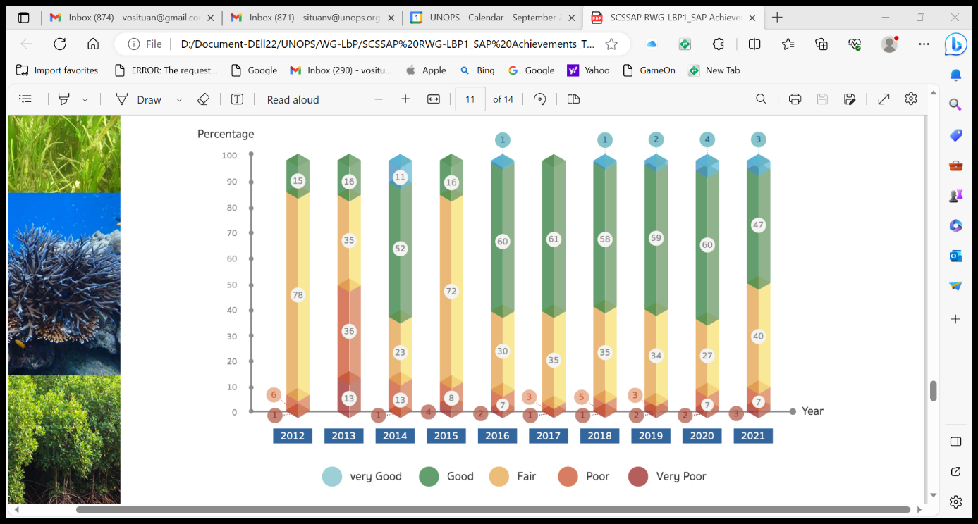

Figure 1. The diagram indicating improvement trend of water quality in Thailand during 2012-2021

3/ Challenges and lessons learnt in implementing the NAP during 2008-2021
3.1. Challenges
Cambodia
- Inadequate of financial source to support for NAP implementation, workshops, and other activities
- Capacity of officials is limited
- Inadequate infrastructure and equipment to deal with plastic waste
- Public awareness of people to participate in LBP management is limited

China
- China’s coastal zone bordering the South China Sea has been developing rapidly.
- There are shortcomings in environmental infrastructure construction such as sewage network and waste treatment facilities in coastal towns and rural areas.
- There are a few of emerging problems and hot issues that the state concerns highly. These issues were not included in the activities of priority sites of the SAP.
- Capacity building needs to be further strengthened.
- Laws, regulations, policies, standards for Marine environmental governance need to be further improved, for example, in some places, Lack of local pollutant discharge standards in mariculture operations.

Indonesia
- Public awareness of certain groups still needs to be improved.
- There are still people in certain areas who have difficulty getting access to sanitation
- Government limitations in providing resources and financing.
- Systematic monitoring program for both sea water quality and marine litter (beach litter, floating litter, and benthic litter) and also riverine inputs since Indonesia has a large ocean area and thousands of watersheds.

Thailand:
- COVID-19 situation generated infectious wastes – masks, ATK, and plastic garbage from food delivery system -> leak to coastal areas
- Private and public involvement is very important for land-based pollution, not only the government sector.
- Raising awareness on entrepreneurs to reduce their wastewater is still needed.

Philippines
The capacity of DENR-EMB to handle their responsibilities in the implementation of these various laws has been continuously upgraded. However, even with much effort, there are still gaps and necessities that are needed to be responded to.

Vietnam
- Although the rate of pollution, environmental degradation, natural resource and biodiversity loss has been controlled, it is still complicated, in some places and areas still at an alarming rate; especially emerging is pollution in some river basins, craft villages, air pollution in some big cities
- Infrastructure for environmental protection, although invested, is still lacking and weak, not meeting the requirements of reality.
- The volume of generated solid waste and hazardous waste is increasing, the composition structure is complicated, while the management capacity at local is still limited.

3.2. Lessons learnt
Cambodia
- Technical steps for developing NAP and implementation
- Report system by online
- Set up working group on water quality controlling and monitoring

China
- Completed governance reform of the organizational structure of ecological environment and natural resources:
- Improved law and regulation systems and formulated more than 20 pollutant discharge standards related to land-based pollution control and prevention:
- The goals and tasks of the SAP were integrated into national /local policy framework and action plans for land-based pollution control:
- Taking an ICARM (integrated coastal area and river basin management) approach, to implement comprehensive measures.
- Established the financing mechanisms to support water pollution control and prevention.

Indonesia
- Some programs that implemented by the government, such as PROPER, Waste/Trash Bank, PAMSIMAS, are quite effective ways to control pollution from land-based of sources.
- To control pollution from land-based sources requires a relatively large investment, the role of the central government is very important in assisting the lack of capacity of local government.
- To change people's behavior to care about the environment, it is necessary to ensure that their activities provide economic benefits.

Philippines
- Maximizing communication/networking with LGUs, the academe and other Government Agencies
- Importance of budget allocation
- Capacity-building of personnel thru online workshop/webinars
- Information dissemination to stakeholders e.g., NGAs, LGUs, NGOs, POs, and the Youth

Thailand
- Permit system for wastewater should be implemented in Thailand, in order to reduce amount of pollution into water
- Strong punishment should be applied
- Admire and reward for the good practice of manufacturers or communities are essential,
- Promote more on using less chemical on agriculture and aquaculture

Vietnam
- Economic development must be in harmony with nature, respect the laws of nature, do not trade the environment for economic growth.
- Environmental protection is the responsibility of the whole political system and the whole society, in which local authorities, businesses, communities and people play an important role.
- Land-based pollution control must be based on institutional quality improvement and effective and effective law enforcement
- Concentrating on environmental management of industrial parks, industrial clusters and craft villages; resolutely review the requirement to have a centralized wastewater treatment system, for large-scale waste dischargers, to install a system of equipment to control and monitor discharge activities; apply sanctions for establishments causing environmental pollution to comply with requirements on environmental protection to implement the technology conversion roadmap
- Increasing the mobilization of resources in the society in combination with increasing budget expenditure; effectively apply the principle that polluters must pay treatment costs and compensation, beneficiaries of environmental values must pay; continue to promote the participation of businesses, organizations, communities and people in environmental protection.

